EXPERIMENT NO. 9

AIM :- To Write YACC program using lex to recognize a valid variable, which starts with letter, followed by any number of letters or digits.

ALGORITHM:-

Step1: Start the program

Step2: Reading an expression

Step3: Checking the validating of the given expression according to the rule using yacc.

Step4: Using expression rule print the result of the given values

Step5: Stop the program

CODE:-

LEX PROGRAM:-

%{

#include "y.tab.h"

%}

%%

[a-zA-Z_][a-zA-Z_0-9]* return letter;

[0-9] return digit;

. return yytext[0];

\n return 0;

%%

int yywrap()

{

return 1;

} %%

YACC PROGRAM:-

%{

#include<stdio.h>

int valid=1;

%}

%token digit letter

%%

start : letter s

s : letter s

| digit s

|

; %%

int yyerror()

{

printf("\nIts not a identifier!\n");

valid=0;

return 0;

}

int main()

{

printf("\nEnter a name to tested for identifier ");

yyparse();

if(valid)

{

printf("\nIt is a identifier!\n");

}

}

OUTPUT:-

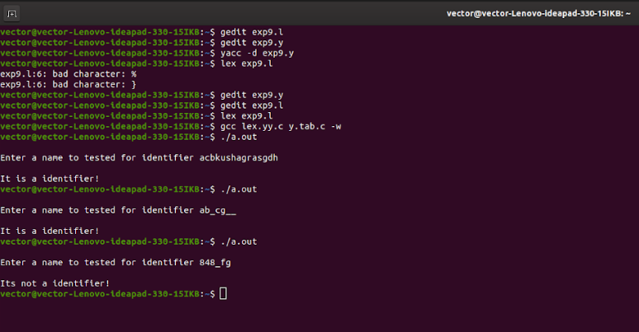

RESULT:- Thus,YACC program using lex to recognize a valid variable, which starts with letter, followed by any number of letters or digits has been successfully executed.